MINISTRY OF EDUCATION AND SCIENCE OF UKRAINE
LUTSK NATIONAL TECHNICAL UNIVERSITY
(Faculty of Business and Law, Marketing Department)
Ukrainian Marketing Association; Volyn Regional Council; Lutsk City Council;
National Academy for Public Administration, Kyiv Dnipro University of Technology
(Marketing Department); Uzhhorod National University
(Department of Business Administration, Marketing and Management);
Politechnika Lublin, Poland; University of Rzeszow, Poland; Silesian University of Technology (SUT), Gliwice, Poland; Wroclaw University of Economics and Business; Polessky State University, Belarus; Vitebsk State Technological University, Belarus; Belarusian Trade-Economic University of Consumer Cooperation; State Agrarian University of Moldova; Polytechnic Institute of Bragança, Portugal; University of National and World Economy, Bulgaria; Polytechnic in Pozega, Croatia

 | 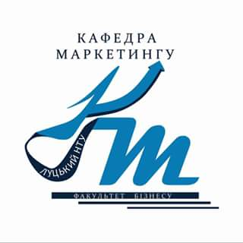 | 
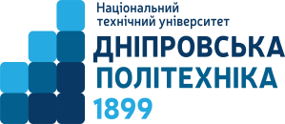 |  |  | 
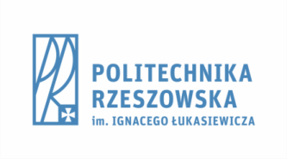 |  |  | 
 |  | 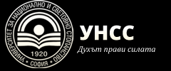 | 

INVITATION

Dear Colleagues!
We invite you to take part in the VIII International Scientific Conference
of students and young scholars
«ACTUAL PROBLEMS OF MANAGEMENT IN MARKETING WITHIN THE FRAMEWORK OF INNOVATIVE ECONOMIC DEVELOPMENT»

The conference will be held at Lutsk National Technical University on March 26, 2021.

Conference goals and objectives – to discuss and generalise the applicants’, postgraduates’ and young scientist’s results of scientific research on current trends and prospects of Marketing Management development in the context of innovative economic development.

CONFERENCE TRACKS:

1. Theory and practice of marketing in enterprise management.
2. Practical implementation of the principles of management in marketing on international and regional levels.
3. Organizational, personnel, financial and accounting, logistics and information support of marketing activities of enterprises.
4. Marketing of innovations and innovations in marketing

Conference Participation Terms and Conditions

Remote form of participation (online meeting via ZOOM video conference system). After receiving the materials (abstracts and application forms), the conference organizing committee will send a link to log in to the ZOOM video conference system. Complimentary registration! The book of abstracts in PDF will be hosted on the website of Lutsk NTU.
Languages: Ukrainian, Russian, English, Polish

TO PARTICIPATE IN THE CONFERENCE YOU HAVE TO:

- fill in and send the application form and abstracts (Google Form)
https://forms.gle/3oFYH9GwP37js6NH6 (Ukr);
https://forms.gle/6Ygh7T9KbG56aXM19 (Rus);
https://forms.gle/73JoqZgtDNpex7aK6 (Engl);
https://forms.gle/dYspiArqj6BTAUDr7 (Pol);
or to e-mail the abstracts for publication on the conference e-mail address: Konfmarkmen2021@gmail.com
- take part in the conference 26.03.2021 on the ZOOM platform (using the link in the participant's personal invitation)
The materials must be submitted until March 19, 2021.

CONFERENCE AGENDA

Friday, March 26, 2021
9³⁰ – Online registration of conference participants in ZOOM
10⁰⁰ – Opening ceremony and plenary session
13⁰⁰ – Lunch break
14⁰⁰ – Breakout session (according to the tracks)

17⁰⁰ – Closing conference

TIME LIMITS ON DEBATES AND LENGTHS OF SPEECHES

Plenary report – 10 min.
Breakout session report. – 5 min.
Debating – 3 min.
Debating controversial matters – 5 min.

REQUIREMENTS TO THE ABSTRACT FORMATTING

The abstracts that have not been published before can be accepted for publication.
Abstract text should be accomplished in MS Word text editor with the following settings: bottom margin – 1.5 cm, top margin – 1.5 cm, left and right margins – 1.5 cm; main text font – Times New Roman, 14 pt; line interval – single.
Abstract text volume should not exceed 2-3 pages of A5 format (148 × 210 mm).
Working languages – Ukrainian, English, Polish, Russian.
Abstract structure
The upper right corner: The 1st line – the author(s) surname and name; The 2nd line – organization(s) name(s) (without abbreviations); The 3rd line – (for PhD students) the Supervisor’s surname and name; The 4th line – the Supervisor’s academic degree and academic status.
The title of the abstract should be printed in bold capital letters symmetrically to the text.
Abstract text should certainly contain references. References should be indicated in square brackets ([n]). Reference list should be placed at the end of the text.
References should be formatted in accordance with current standard.
The file name should correspond to the author’s or the 1-st co-author’s surname (e.g.: Solomon.doc).
The submitted abstract should be relevant with the conference tracks. In case of irrelevancy the Organizing Committee may reject the abstract.
The submitted abstract should be carefully edited. Abstracts will be published in the author's edition. The authors of the released abstracts are fully responsible for compilation and accuracy of the facts, citations, economic and statistical data, terminology, and other information.
Materials that do not meet the requirements will not be hosted on the website and will not be published.

Example of abstract formatting
Serhiichuk Ivanna
Lutsk National Technical University
(for students) Supervisor: Ivanov Ivan,
D.Sc. Economics, Professor, Lutsk NTU

projecting of MARKETING TOOLS of INFLUENCE on THE BEHAVIOR OF THE final customer OF CONFECTIONERY PRODUCTS

Abstract text Abstract text Abstract text Abstract text Abstract text Abstract text Abstract text Abstract text Abstract text Abstract text Abstract text Abstract text Abstract text Abstract text Abstract text Abstract text.

(ABSTRACT TEXT VOLUME (INCLUDING REFERENCE LIST) SHOULD NOT EXCEED 2-3 PAGES)

Reference list:

(minimum three sources)

ORGANIZING COMMITTEE
Chairperson of organizing committee
Iryna Vakhovych, Rector of Lutsk NTU, D.Sc. Economics, Professor, Lutsk NTU

Deputy chairpersons
+380956584524 Nadiia Kovalchuk, Pro-Rector for Academic Affairs, Research and Partnership, PhD, Associate Professor, Lutsk NTU;
+380501554555 Iryna Kaminska, Dean of Business and Law Faculty, PhD, Associate Professor, Lutsk NTU;
+380956115100 Valentyna Morokhova, Head of Marketing Department, PhD, Professor, Lutsk NTU;
+380957773280 Serhii Voitovych, PhD, Professor, Lutsk NTU.
Executive secretary
+380505576265 Iryna Lorvi, PhD, Associate Professor, Lutsk NTU.

